Poetry Booklet Requirements

- Poetry booklet should have a cover page with your name. Also, create a title for your book of poetry. (Each poem written should also have a title.)
- Poetry booklet must include a table of contents. This should include the title of the poem, as well as the type of poem on that page (diamante, acrostic…)
- Include illustrations and color throughout the booklet.
- Place only one poem on each page. Be sure to include the title of the poem.
- Effort should be made to make sure poems are written neatly and illustrations are neat as well. Poems may be typed or hand-written neatly. Clip art may be used. Hand drawn illustrations are also encouraged.

You should select FOUR of the following types of poems for your booklet:

- Haiku
- Diamante
- Acrostic
- Cinquain
- Concrete or shape poem
- Color poem
- “I can’t write a poem” poem

*Samples and formats for the above listed poems are included in this packet.*

Haiku

- Unrhymed poetry
- Usually about nature
- Short – about a single idea
- Topics include: flowers, trees, animals, seasons, and weather

3 lines:
1. 5 syllables
2. 7 syllables
3. 5 syllables

Sample:
Warm April sunrise
Tender green shoots pierce the soil,
Aiming for the sun

Diamante Poem

A diamante is a 7-line poem that is shaped like diamond.
Format:

Line 1: | one word  (subject/noun that is contrasting to line 7)
Line 2: | two words  (adjectives) that describe line 1
Line 3: | three words  (action verbs) that relate to line 1
Line 4: | four words (nouns)  first 2 words relate to line 1  last 2 words relate to line 7
Line 5: | three words  (action verbs) that relate to line 7
Line 6: | two words  (adjectives) that describe line 7
Line 7: | one word  ( subject/noun that is contrasting to line 1)

Sample:
Cat
Finicky, anti-social
Meows, purrs, naps
Pets, animals, companions, friend
Bark, fetch, run
Loyal, playful
Dog
Acrostic Poem

An acrostic poem is a poem or series of lines, where the letters spell another word.
“Halloween”
Halloween is dark and gloomy,
And a scary trick or treat,
Lots of children scaring adults,
Lovely costumes to wear,
On the table a scary pumpkin,
White ghosts all round,
Eek a witch by a cauldron,
Enough of all the costumes, they are scary,
Night time is scary on Halloween.

Cinquain

(From the French word for “five”)
Can be about anything.

- topic (2 syllables)
- Description of topic (4 syllables)
- Actions that fit that topic (6 syllables)
- Feelings about the topic (8 syllables)
- Another word for your topic (2 syllables)

Chorus
Many voices
Creating Harmony
Joyous, hopeful, graceful, dreamy
Music

Concrete (or shape) Poems

Concrete (or shape) poetry is in a form where the poetry takes on the shape of its subject.

Sample:
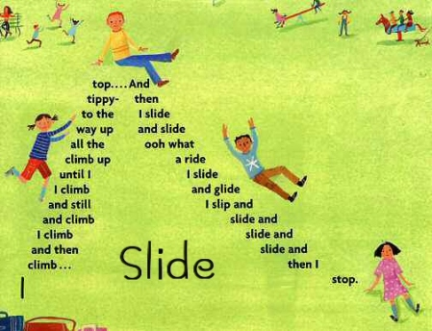

Color Poem

Line 1
Name a color
Lines 2-4
Name 3 things that are that color
Lines 5-7
Name 3 things that sound like that color
Lines 8-10
Name 3 things that taste like that color
Lines 11-13
Name 3 things that feel like that color
Line 14
What can that color do?

Sample:
Purple
A bruise on your leg,
Bunches of grapes in a bowl,
A sweater that goes great with black,
The sound of power,
Fruit juice poured into a glass
A school bell ringing, ringing
Grandma's rhubarb pie.
Cold medicine served up on a tablespoon
Squishy cough drops,
Velvet covered cushions
Pointy tip pentel markers,
The sky before lightning starts
Purple can take you for a sweet ride.
"I Can't Write a Poem" Poem

Line 1: Forget it
Line 2: You must be kidding
Line 3: Excuse #1
Line 4: Excuse #2
Line 5: Excuse #3
Line 6: Excuse #4
Line 7: Excuse #5
Line 8: Excuse # 6
Line 9: Excuse #7
Line 10: Excuse #8
Line 11: Time's up? Uh oh!
Line 12: All I have is a dumb list of excuses.
Line 13: You like it? Really? No kidding.
Line 14: Thanks a lot. Would you like to see another one?

Sample:
“I Can't Write a Poem”
Forget it.
You must be kidding.
I'm still half asleep.
My eyes keep closing.
My brain isn't working.
I don't have a pencil.
I don't have any paper.
My desk is wobbly.
I don't know what to write about.
And besides, I don't even know how to write a poem.
I've got a headache. I need to see the nurse.
Time's up? Uh oh!
All I have is a dumb list of excuses.
You like it? Really? No kidding.
Thanks a lot. Would you like to see another one?

