 | Cafeteria  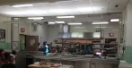 | Hallway  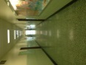 | 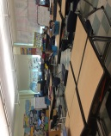  Learning Environment | Bathroom  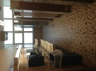 | Assemblies  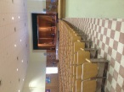 | Playground  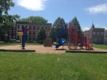 | Bus  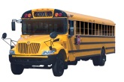
Be Safe | *Keep hands, feet and objects to yourself  *Walk carefully  *Stay alert  *Stay in your seat  *Stay seated until your table is called  *Wait patiently | *Keep hands, feet and objects to yourself  *Walk carefully  *Stay alert  *Walk on the arrows  *Stay to the right | *Keep hands, feet and objects to yourself  *Walk carefully  *Stay alert  * Use materials appropriately | *Keep hands, feet and objects to yourself  *Walk carefully | *Keep hands, feet and objects to yourself  *Stay seated | *Keep hands, feet and objects to yourself  *Move carefully  *Play safely  *Stay in designated area  *Line up when called  *Use playground equipment appropriately | *Stay seated  *Face forward  *Keep hands, feet and objects to yourself
Be  Respectful | *Use encouraging, polite and kind words  *Use a speaking voice  *Raise your hand if you need help | *Quiet wave  *Appropriate voice  *Be respectful of others work | * Listen and talk at appropriate times  *Use encouraging, polite and kind words  *Be an active participant  *Use an appropriate voice | *Honor others privacy  *Use a speaking voice  *Use polite and kind words | *Use encouraging, polite and kind words  *Listen and respond appropriately  *Use the appropriate voice level  *Enter and exit quietly  *Wait patiently | *Use encouraging, polite and kind words  *Include others  *Share  *Take turns  *Help others  *Be a good sport | *Use encouraging, polite and kind words  *Listen to the driver  *Speaking voices  *Respect property
Be  Responsible | ** Keep area clean  *Throw away trash when table is called  *Accept consequences graciously | *Keep hallways clean  *Stay with the line  *Go straight to your destination  *Report any incidents to an adult  *Accept consequences graciously | *Complete classwork and homework  *Work hard and do your best  *Accept consequences graciously  *Be prepared and ready for the day  *Listen and follow directions quickly  *Keep materials organized | *Keep bathrooms clean and throw away trash  *Flush  *Wash your hands  *Get in and out in a timely manner  *Report any incidents to an adult  *Use the bathroom for its purpose | *Follow directions  *Accept consequences graciously | *Follow directions  *Accept consequences graciously  *Report any incidents to an adult  *Take care of and return playground toys | *Keep the bus clean  *Follow the rules of the bus  *Keep track of your belongings  *Report any incidents to an adult

